Jack Crawford

2 November, 2017

Reading Level Report

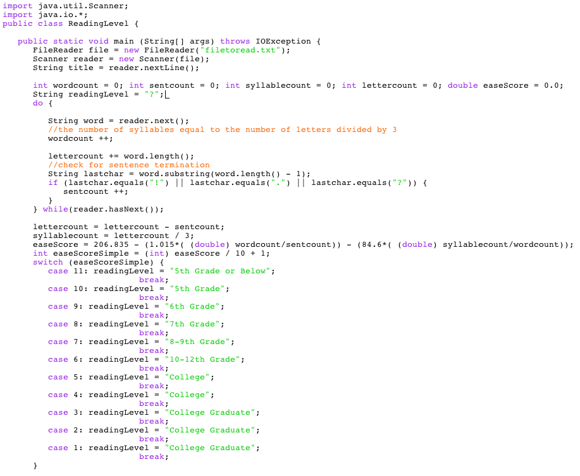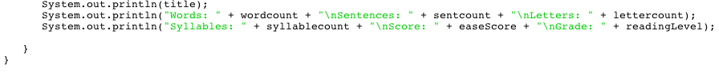

Text Used:

 1 An assortment of quotes from Dune:  
 2   
 3 I must not fear. Fear is the mind-killer.  
 4 Fear is the little-death that brings total obliteration.   
 5 I will face my fear. I will permit it to pass over me and through me.   
 6 And when it has gone past I will turn the inner eye to see its path.   
 7 Where the fear has gone there will be nothing. Only I will remain.  
 8   
 9 A beginning is the time for taking the most delicate care that the balances are   
10 correct. This every sister of the Bene Gesserit knows. To begin your study of   
11 the life of Muad'Dib, then, take care that you first place him in his time: born   
12 in the 57th year of the Padishah Emperor, Shaddam IV. And take the most special   
13 care that you locate Muad'Dib in his place: the planet Arrakis. Do not be   
14 deceived by the fact that he was born on Caladan and lived his first fifteen   
15 years there. Arrakis, the planet known as Dune, is forever his place,   
16 -from "Manual of Muad'Dib" by the Princess Irulan   
17   
18 In the week before their departure to Arrakis, when all the final scurrying   
19 about had reached a nearly unbearable frenzy, an old crone came to visit the   
20 mother of the boy, Paul.   
21   
22 It was a warm night at Castle Caladan, and the ancient pile of stone that   
23 had served the Atreides family as home for twenty-six generations bore that   
24 cooled-sweat feeling it acquired before a change in the weather.   
25   
26 The old woman was let in by the side door down the vaulted passage by Paul's   
27 room and she was allowed a moment to peer in at him where he lay in his bed.   
28   
29 By the half-light of a suspensor lamp, dimmed and hanging near the floor,   
30 the awakened boy could see a bulky female shape at his door, standing one step   
31 ahead of his mother. The old woman was a witch shadow — hair like matted   
32 spiderwebs, hooded 'round darkness of features, eyes like glittering jewels.

Output:

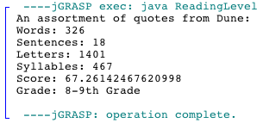

Details:

Time to build - 25 minutes.